Foundry
(important notes and highlights)
Installed on linux or WSL. Search for installing Foundry
Can be updated using foundryup command
</> bash
foundryup
Check if installed using:
</> bash
anvil --version
Let’s Begin!

Init and compile
To start a new project:
</> bash
forge init
delete the default src and script and test files and replace it with your own!
to compile the code:
</> bash
forge build
or
</> bash
forge compile
When running anvil we get:

_ _
(_) | |
__ _ _ __ __ __ _ | |
/ _` | | '_ \ \ \ / / | | | |
| (_| | | | | | \ V / | | | |
\__,_| |_| |_| \_/ |_| |_|

1.7.1 (4072e48705 2026-05-08T07:50:55.527285345Z)
https://github.com/foundry-rs/foundry

Available Accounts
==================

(0) 0xf39Fd6e51aad88F6F4ce6aB8827279cffFb92266 (10000.000000000000000000 ETH)
(1) 0x70997970C51812dc3A010C7d01b50e0d17dc79C8 (10000.000000000000000000 ETH)
(2) 0x3C44CdDdB6a900fa2b585dd299e03d12FA4293BC (10000.000000000000000000 ETH)
(3) 0x90F79bf6EB2c4f870365E785982E1f101E93b906 (10000.000000000000000000 ETH)
(4) 0x15d34AAf54267DB7D7c367839AAf71A00a2C6A65 (10000.000000000000000000 ETH)
(5) 0x9965507D1a55bcC2695C58ba16FB37d819B0A4dc (10000.000000000000000000 ETH)
(6) 0x976EA74026E726554dB657fA54763abd0C3a0aa9 (10000.000000000000000000 ETH)
(7) 0x14dC79964da2C08b23698B3D3cc7Ca32193d9955 (10000.000000000000000000 ETH)
(8) 0x23618e81E3f5cdF7f54C3d65f7FBc0aBf5B21E8f (10000.000000000000000000 ETH)
(9) 0xa0Ee7A142d267C1f36714E4a8F75612F20a79720 (10000.000000000000000000 ETH)

Private Keys
==================

(0) 0xac0974bec39a17e36ba4a6b4d238ff944bacb478cbed5efcae784d7bf4f2ff80
(1) 0x59c6995e998f97a5a0044966f0945389dc9e86dae88c7a8412f4603b6b78690d
(2) 0x5de4111afa1a4b94908f83103eb1f1706367c2e68ca870fc3fb9a804cdab365a
(3) 0x7c852118294e51e653712a81e05800f419141751be58f605c371e15141b007a6
(4) 0x47e179ec197488593b187f80a00eb0da91f1b9d0b13f8733639f19c30a34926a
(5) 0x8b3a350cf5c34c9194ca85829a2df0ec3153be0318b5e2d3348e872092edffba
(6) 0x92db14e403b83dfe3df233f83dfa3a0d7096f21ca9b0d6d6b8d88b2b4ec1564e
(7) 0x4bbbf85ce3377467afe5d46f804f221813b2bb87f24d81f60f1fcdbf7cbf4356
(8) 0xdbda1821b80551c9d65939329250298aa3472ba22feea921c0cf5d620ea67b97
(9) 0x2a871d0798f97d79848a013d4936a73bf4cc922c825d33c1cf7073dff6d409c6

Wallet
==================
Mnemonic: test test test test test test test test test test test junk
Derivation path: m/44'/60'/0'/0/

Chain ID
==================

31337

Base Fee
==================

1000000000

Gas Limit
==================

30000000

Genesis Timestamp
==================

1784657479

Genesis Number
==================

0

Listening on 127.0.0.1:8545
Which gives us a list of accounts etc. just like remix.
In metamask we make a localhost network to start working with the port from anvil:
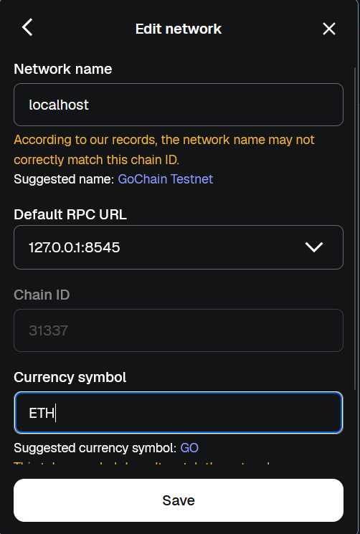

Deploy
Now we run the anvil in a terminal and let it listen on the localhost, open another terminal and use this command to deploy:
</> bash
forge create contract_name --interactive
it prompts and asks for a private key, Copy one of the private keys from the anvil terminal and paste. And valla!
[⠊] Compiling...
No files changed, compilation skipped
Warning: Dry run enabled, not broadcasting transaction

Contract: SimpleStorage
Transaction: {
"from": "0xf39fd6e51aad88f6f4ce6ab8827279cfffb92266",
"to": null,
"maxFeePerGas": "0x77359401",
"maxPriorityFeePerGas": "0x1",
"gas": "0x856a5",
"input": "0x6080604052348015600e575f5ffd5b506108ec8061001c5f395ff3fe608060405234801561000f575f5ffd5b5060043610610055575f3560e01c80632e64cec1146100595780632ebce631146100775780636057361d146100a85780636f760f41.
.
.
.
Etc
Overall, to deploy your contract to any chain on the blockchain here is the command:
</> bash
forge create [contract_name] --rpc-url [the_URL] --private-key [the_key_to_your_acc]
safer to use interactive because your private key won’t stay in your terminal history. At least you can delete the history like this:
</> bash
history -c
now for better automation we are gonna use scripts!

Scripts
In scripts we make a new .s.sol file as a script:
// SPDX-License-Identifier: MIT
pragma solidity ^0.8.0;

import {Script} from "forge-std/Script.sol";
import {SimpleStorage} from "../src/SimpleStorage.sol";

contract DeploySimpleStorage is Script {
function run() external returns (SimpleStorage) {
vm.startBroadcast();
SimpleStorage simpleStorage = new SimpleStorage();
vm.stopBroadcast();
return simpleStorage;
}
}
Then hit this command:
</> bash
forge script script/DeploySimpleStorage.s.sol
the result:
Compiler run successful!
Script ran successfully.
Gas used: 514752

== Return ==
0: contract SimpleStorage 0x7FA9385bE102ac3EAc297483Dd6233D62b3e1496

If you wish to simulate on-chain transactions pass a RPC URL.
This will automatically run anvil with some private key and test it temporarily no real deployment.
Now doing it with anvil running:
</> bash
forge script script/DeploySimpleStorage.s.sol --rpc-url http://127.0.0.1:8545
result:
Script ran successfully.

== Return ==
0: contract SimpleStorage 0x5b73C5498c1E3b4dbA84de0F1833c4a029d90519

## Setting up 1 EVM.

==========================

Chain 31337

Estimated gas price: 2.000000001 gwei

Estimated total gas used for script: 710409

Estimated amount required: 0.001420818000710409 ETH

==========================

SIMULATION COMPLETE. To broadcast these transactions, add --broadcast and wallet configuration(s) to the previous command. See forge script --help for more.

Transactions saved to: /home/arsham/foundry-projects/foundry-simple-storage/broadcast/DeploySimpleStorage.s.sol/31337/dry-run/run-latest.json
Is it deployed now?
Answer: No, the output indicates this was a simulation.
Also a broadcast folder is added that has a history of our script runs.
For a real deployment to blockchain, hit the up arrow key and add --broadcast --private-key 0xac0974bec39a17e36ba4a6b4d238ff944bacb478cbed5efcae784d7bf4f2ff80 at the end.
forge script script/DeploySimpleStorage.s.sol --rpc-url http://127.0.0.1:8545 --broadcast --private-key 0xac0974bec39a17e36ba4a6b4d238ff944bacb478cbed5efcae784d7bf4f2ff80
Our contract is now successfully deployed!
An important point:
You start Anvil:
- Anvil creates a fresh in-memory blockchain.
- You deploy contracts using one of the provided private keys.
- The contracts exist only in that running Anvil instance.
- When you press Ctrl+C:
  - the blockchain state is lost,
  - all deployed contracts disappear,
  - account balances, nonces, storage, etc. are reset.
The next time you run:
anvil
Anvil starts from block 0 again with a brand-new chain. Your previously deployed contracts will not be there, even though the private keys are the same.
If you want persistence
Anvil supports loading/saving state or forking from another chain.
For example, you can save the state:
</> bash
anvil --dump-state state.json
dry runs and other runs are all stored in broadcast folder:
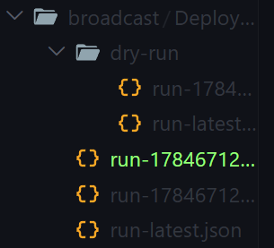
As we know transactions have a nonce that show the # of Txs from an acc. If I run anvil, deploy, hit ctrl + c and re-run anvil and deploy the nonce in both runs will be 0x0 because these are deployed on 2 different blockchains!
The first run Tx in broadcast:
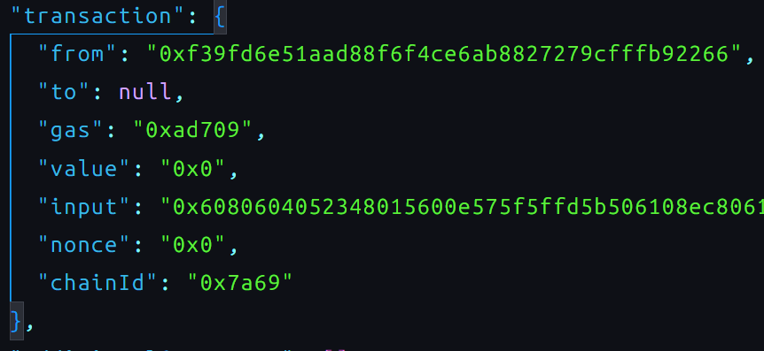
The second run:

Exactly the same!
But if we deploy again in the same anvil bash the nonce will be incremented:
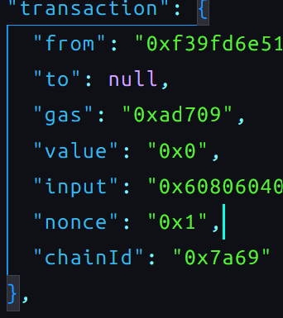
you can use the cast command to cat hex to dec like this:
</> bash
cast --to-base 0x714e1 dec

